EXPERIMENT 3

AIM:
To detect γ radiation produced by ¹³⁷Cs with a scintillator counter using a single channel analyser.
- Energy spectrum is obtained and analysed.
- Resolution of the SCA instrument is measured.

SOURCE:
γ-ray source used in this experiment is ¹³⁷Cs (1 peak)

THEORY:
1) β⁻ decay:
- β⁻ decay occurs as follows:

n p + e⁻ + ${\overline{ν}}_{e}$

n – neutron
p – proton
e⁻ - electron (called the β particle)
${\overline{ν}}_{e}$ – antineutrino

- The mass number (p + n) remains the same whereas the atomic number (p) increases.
- e⁻ and ${\overline{ν}}_{e}$ are released to conserve charge, energy and momentum. They carry away the energy and momentum.

2) Decay of ¹³⁷Cs:
- ¹³⁷Cs (Z = 55) decays into ^{137m}Ba (Z = 56) (m – metastable, meaning it is not the most stable nuclear state) through β⁻ decay.
- The β⁻ decay energy spectrum is a continuous spectrum since the energy emitted in the decay is shared between the antineutrino and the e⁻.
- The β particle (e⁻) can have a maximum energy of 512 keV, when the antineutrino has almost 0 energy.
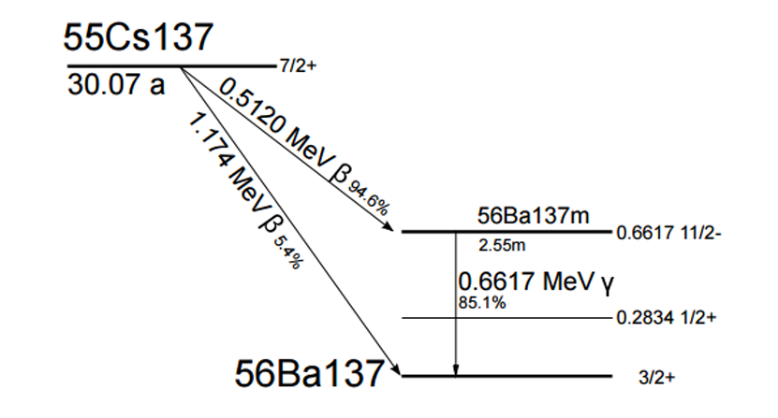
- ^{137m}Ba releases a gamma photon, having a characteristic energy of 662 keV to reach its ground state. This is what is detected by the scintillator counter as the peak of the ¹³⁷Cs distribution.
Figure 1: Decay scheme of Cs-137

3) Detection by scintillator counter:
- The counter has scintillator crystals (like NaI(Tl)). When the γ-ray emitted (662 keV) enters the crystal, it can lose its energy by the following processes:

- Photoelectric Effect: γ photon absorbed, e⁻ ejected.
- Compton Scattering: γ photon scatters, e⁻ gets energy.
- Pair Production: If energy > 1.022 MeV, not relevant here.
In all the cases, the γ-ray energy is transferred to fast-moving e⁻s.
- The energetic electrons collide with other atoms of the crystal, exciting them. In pure NaI, these would have mostly returned to the ground state without producing visible light.
- This is why Thallium (Tl) is added as an activator. Excited e⁻s transfer their energy to Tl⁺ ions, which then return to ground state, emitting visible light photons ($λ$ $\sim$ 410 nm)
- This “scintillation” is efficient and gives a burst of light proportional to the γ-ray’s energy.
4) Photomultiplier Tube (PMT):
- The PMT has a photocathode coating. When it is hit by scintillation light, it knocks out photoelectrons by the photoelectric effect. The following is valid:

No. of emitted e⁻ $∝$ No. of photons $∝$ Energy of the γ-ray

- These electrons are directed towards a series of electrodes (dynodes), each at a higher positive voltage than the previous one.
- When an e⁻ strikes the 1st dynode, it ejects several secondary e⁻s. Each secondary e⁻ is accelerated to the next dynode, producing more electrons at each stage. After 10-12 dynodes, the initial few electrons are multiplied into millions.
- This large cloud of electrons reaches the anode, producing a measurable current pulse. The pulse height is proportional to the original number of scintillation photons, which is proportional to the γ-ray’s energy.
- If there are 10 dynodes, each at 50 V higher than the previous one, then total voltage gap:

V_{Total} = (50 x 100) V = 500 V
This is called the PMT Voltage or HV (High Voltage).
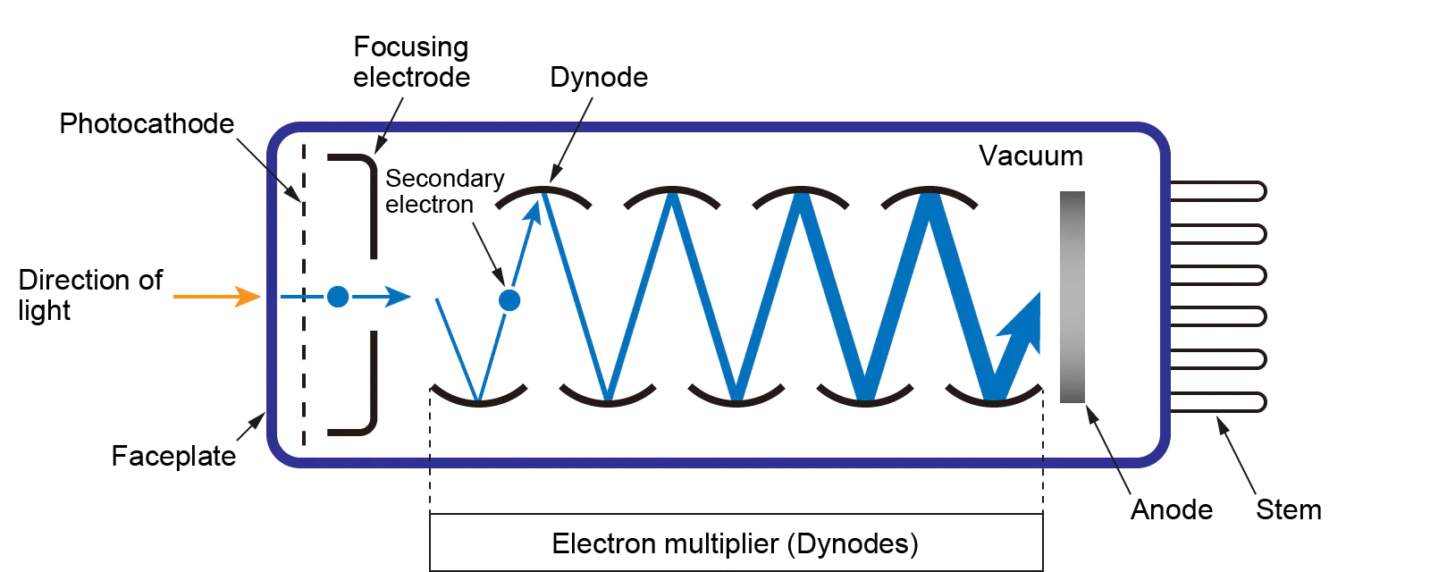
Figure 2: Structure of PMT

5) Single Channel Analyser (SCA):
- The scintillator + PMT produce pulses of varying amplitudes (heights).
- The SCA selects pulses only in a certain energy range by setting 2 limits:

- A lower discriminator (Baseline)
- An upper discriminator (Baseline + Window)

- Baseline (Low Level Discriminator (LLD)) is the minimum acceptable pulse height. Pulses smaller than this are rejected.
- The window defines the range of pulse heights above the baseline that will be accepted.
- For example, if:
- Baseline = 600 keV
- Window = 50 keV,
The SCA will only accept pulses between 600 and 650 keV. This is to select the 662 keV γ-peak of ¹³⁷Cs, while rejecting Compton background.

5) Compton Scattering:
- In this case, the γ-ray is not absorbed but scattered through an angle $θ$ by the electron, which recoils and carries away some of the energy of the gamma ray.
- The scattered electron energy is detected by the PMT. The gamma-ray escapes from the scintillator as the probability that a gamma-ray Compton scatters in the scintillator is quite small.
- The equation for energy of scattered electron is:

$$E'= \frac{\frac{E^{2}}{mc^{2}}(1-\cos{θ)}}{1+\frac{E}{mc^{2}}(1-\cos{θ)}}$$

E = energy of gamma-ray
E’ = energy of scattered electron
$θ$ = angle of scattering
m = mass of electron
c = speed of light

- At $θ$ = 0º: E’ = 0 (minimum energy of electron).
At $θ$ = 180º: E’ = $\frac{2E^{2}}{{mc}^{2}+2E}$ (maximum energy of electron). This maximum energy is called the Compton edge. For E = 662 keV, it is around 478 keV.

The energy of the electron lies in this range.

6) Energy Spectrum of Cs-137:
The energy spectrum of ¹³⁷Cs has the following features:
- Photo-peak (662 keV): This is the main γ-line of ¹³⁷Cs. It occurs when the γ-ray is fully absorbed in the detector, usually by the photo-electric effect. All the γ-energy is transferred to 1 single electron which produces a single peak.
- Compton continuum & Compton Edge: When a γ-photon undergoes Compton scattering, it transfers only part of its energy to an electron. This creates a broad continuum. The Compton edge is the maximum energy transfer possible in a single Compton event (478 keV)
- Back-scattering peak: Some γ-rays scatter by 180º before re-entering the detector. The back-scattered γ-photon has an energy of about 184 keV. Hence the detector registers a small peak at that energy.
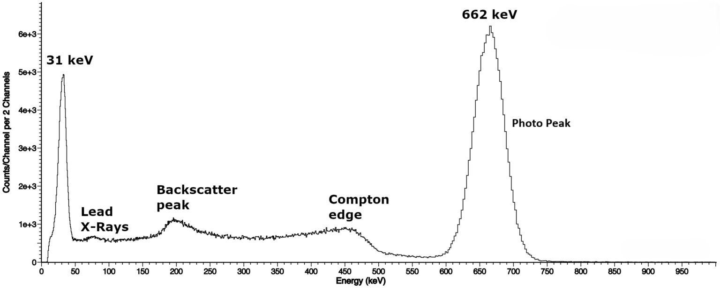
- Ba X-rays: The $β^{-}$ emission (and subsequent processes) can produce characteristic X-rays of Barium (30-35 keV). They appear as small peaks at low energy in the spectrum.
Figure 3: Energy Spectrum of Cs-137

OBSERVATIONS:
HV Adjust: 600 V
Window: 0.1 V
Mode: Window (WIN)
Amplitude/Gain: 2.64
Source: ¹³⁷Cs

Table 1: Variation of counts with Baseline
Baseline (V) | Run 1 | Run 2 | Average (Count for 30s)
0.5 | 439 | 467 | 453
0.54 | 1353 | 1363 | 1358
0.58 | 2159 | 2139 | 2149
0.62 | 2215 | 2183 | 2199
0.66 | 2208 | 2258 | 2233
0.7 | 2343 | 2271 | 2307
0.74 | 2258 | 2213 | 2235.5
0.78 | 2644 | 2639 | 2641.5
0.82 | 3015 | 3104 | 3059.5
0.86 | 3313 | 3298 | 3305.5
0.9 | 2995 | 3148 | 3071.5
0.94 | 2826 | 2808 | 2817
0.98 | 2514 | 2678 | 2596
1.02 | 2427 | 2409 | 2418
1.06 | 2146 | 2264 | 2205
1.1 | 2160 | 2079 | 2119.5
1.14 | 2109 | 1998 | 2053.5
1.18 | 2065 | 1973 | 2019
1.22 | 1868 | 1969 | 1918.5
1.26 | 1849 | 1847 | 1848
1.3 | 1908 | 1967 | 1937.5
1.34 | 1876 | 1897 | 1886.5
1.38 | 1807 | 1864 | 1835.5
1.42 | 1894 | 1962 | 1928
1.46 | 1759 | 1983 | 1871
1.5 | 1795 | 1807 | 1801
1.54 | 1892 | 1878 | 1885
1.58 | 1797 | 1841 | 1819
1.62 | 1578 | 1653 | 1615.5
1.66 | 1298 | 1245 | 1271.5
1.7 | 878 | 838 | 858
1.74 | 682 | 668 | 675
1.78 | 523 | 537 | 530
1.82 | 415 | 469 | 442
1.86 | 365 | 372 | 368.5
1.9 | 350 | 358 | 354
1.94 | 292 | 289 | 290.5
1.98 | 354 | 342 | 348
2.02 | 437 | 431 | 434
2.06 | 864 | 915 | 889.5
2.1 | 1861 | 1985 | 1923
2.14 | 4959 | 4934 | 4946.5
2.18 | 9120 | 8957 | 9038.5
2.22 | 11952 | 11928 | 11940
2.26 | 11603 | 11647 | 11625
2.3 | 7904 | 7953 | 7928.5
2.34 | 3767 | 3717 | 3742
2.38 | 1381 | 1343 | 1362
2.42 | 459 | 439 | 449
2.46 | 184 | 164 | 174
2.5 | 177 | 147 | 162
2.54 | 135 | 123 | 129
2.58 | 102 | 135 | 118.5
2.62 | 104 | 96 | 100
2.66 | 94 | 89 | 91.5
2.7 | 83 | 98 | 90.5

CALCULATIONS:
The gamma spectrum of Cs-137 (Counts v/s Baseline (V)) is plotted below (Figure 4).
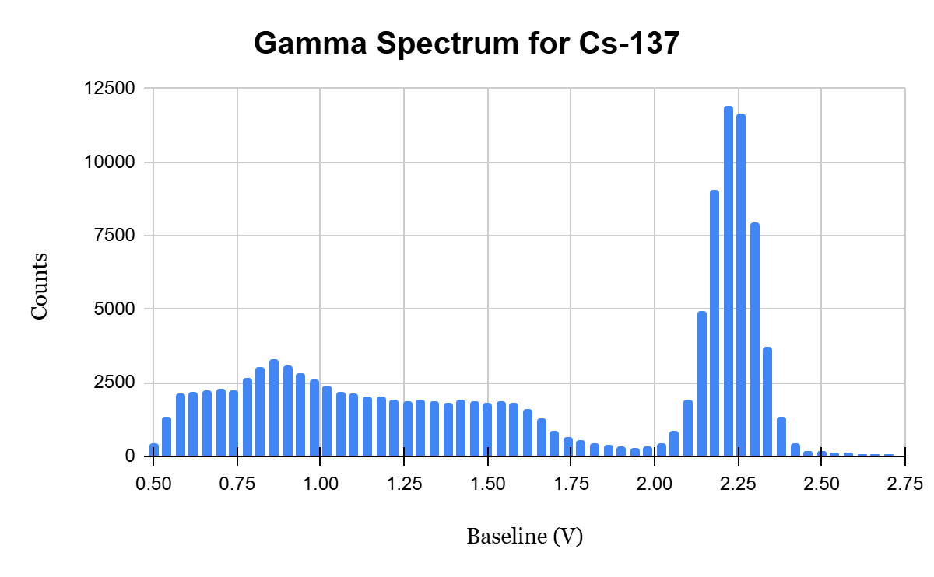
Back-scatter Peak
Photopeak
Compton Edge
Figure 4: Plot of Counts v/s Baseline (V)
As can be seen, the photo-peak appears near 2.25 V. Taking the points near the photo-peak and fitting them with a Gaussian function, the Baseline voltage at which the peak appears is 2.23 V. The Gaussian fit of the points near the peak is plotted in Figure 5. From the plot:

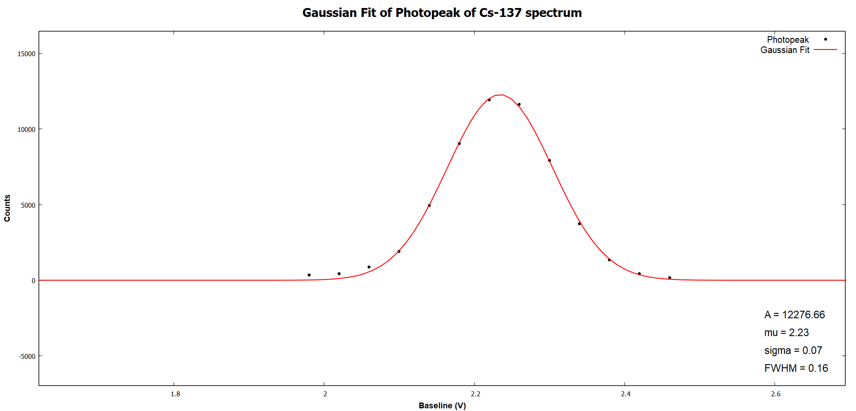
From the plot:
Figure 5: Gaussian Fit of Photopeak

$Amplitude \left(A\right)=12276$ (maximum counts)
$$μ=2.23 V$$
$$σ=0.07 V$$
$$FWHM=2\sqrt{2}σ=0.16 V$$

The peak for Cs-137 occurs at 662 keV. In the graph, this occurs at 2.23 V. Thus, to convert from baseline voltage (V) to energy (keV), the calibration is:
$$E=\frac{662}{2.23} ×V_{B}$$

E = energy in keV
$V_{B}$ = baseline voltage in volts

Compton Edge:
According to theoretical calculations, the Compton Edge occurs at 478 keV.
$$V_{B}= \frac{2.23}{ 662}×478=1.61 V$$

Back-scatter Peak:
The energy of the scattered gamma-ray in Compton scattering is:
$$E_{γ}^{'}=\frac{E}{1+\frac{E}{mc^{2}}\left(1-\cos{θ}\right)}$$

$E_{γ}^{'}$ = Energy of scattered gamma-ray
$E$ = energy of gamma-ray
For E = 662 keV, $θ$ = 180º (back-scattering), $E_{γ}^{'}$ = 184 keV
$$V_{B}=\frac{2.23}{662}×184=0.62 V$$

Resolution of SCA:
The resolution can be determined using the formula:
$$R= \frac{δE}{E} ×100 \%$$

R = resolution
$δE$ = Full width at half-maximum (FWHM)
$E$ = Energy of photo-peak
Since $\frac{ δV}{V}= \frac{δE}{E}$ :
$$R=\frac{0.16}{2.23} ×100=7.17 \%$$

SOURCES OF ERROR:
- Statistical Error: Radioactive decay is a random process. The number of counts in a fixed time interval varies. The uncertainty is proportional to $\sqrt{N}$.
- Instrumental Errors: Not all gamma-rays are fully absorbed in the scintillator. Some may escape, affecting photo-peak intensity. Low-energy pulses from background may be miscounted.
- Background Radiation: Cosmic rays, environmental radioactivity or nearby sources can add extra counts, shifting the photo-peak. It can be corrected by measuring background separately.
- Data Processing: Incorrect calibration, poor binning of data for histogram preparation or fitting errors can distort the parameters (A, µ, $σ$) of the spectrum.

CONCLUSION:
- The photo-peak appears at 2.23 V.
- The FWHM of the photo-peak is 0.16 V.
- The Compton Edge appears at 1.61 V.
- The back-scatter peak appears at 0.62 V.
- The resolution of the instrument is 7.17%.

